Building Enterprise Financial Software in 2026

Part 2: How to stack the deck in your favour
In Part 1, I argued that AI changes the economics of building enterprise financial software, but not the need for discipline. This second part is about the practical side: what made AI useful rather than chaotic while building a large post-trade platform from scratch.
The short version is this:
AI works best when the system gives it fewer bad choices.
That means familiar technology, consistent architecture, clear domain language, executable specifications, guardrails, and aggressive review. The faster the model can recognise the shape of the work, the less it has to infer. The less it has to infer, the better the result.

What changed in practice
The practical result was speed, but not the kind of speed that comes from skipping discipline.
The application reached deployment stage in Docker containers in roughly the equivalent of nine to twelve person-months of effort, compressed into a much shorter calendar period. Without AI, I would expect a comparable effort to require a team of perhaps seven to ten people over a couple of years.
That does not mean AI replaces the team. It means AI changes the economics of what a deeply experienced generalist can do when the work is structured properly.
The speed came from a combination of factors:
- choosing proven technologies
- creating repeatable patterns
- using BDD as executable specification
- reviewing aggressively
- refactoring when patterns repeated
- keeping domain language consistent
- asking AI for options before committing to infrastructure decisions
- slowing down when the problem was not yet well understood
When the knowns were known and the plan was clear, AI was extremely fast. When the problem was fuzzy, AI needed human judgement. That distinction shaped the whole development process.
Fred Brooks' “No Silver Bullet” warning still applies: there is no single breakthrough that removes the essential complexity of software. I still think that is true. AI does not remove the essential complexity of enterprise financial systems. But it can reduce a great deal of accidental complexity, especially around repetitive implementation, test scaffolding, documentation, refactoring, and pattern completion.

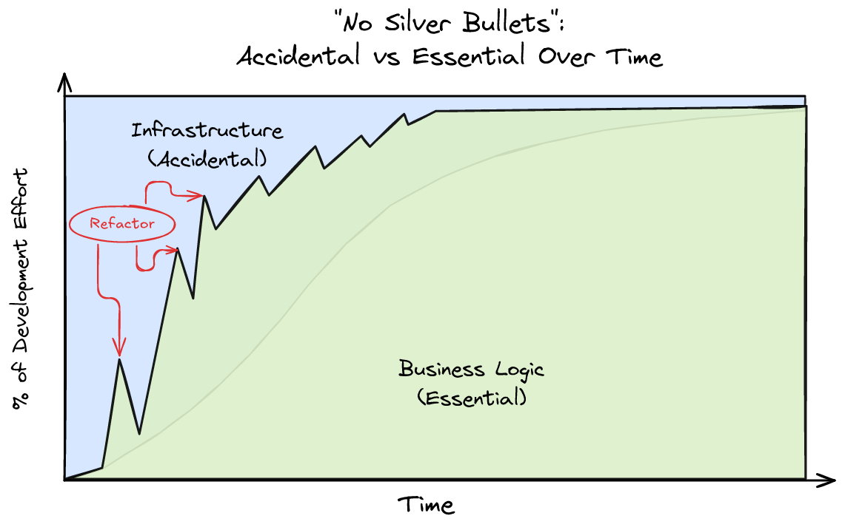

Stack the deck
Large language models are probabilistic. They generate likely answers based on training data, context, and instruction. That means the best results come when the model is operating in a domain with a large, high-quality body of existing knowledge and when the task reduces ambiguity.
Since the models are probabilistic, and probability has a long association with gambling, the aim is to give yourself a stacked deck. As a slightly useless but pleasing side fact, Bayes' theorem came from Thomas Bayes, a theologian rather than a gambler, and sits in that older tradition of reasoning from evidence, including arguments about whether the hand of God could be inferred from the world. That is not a bad frame for AI-assisted development: use the evidence available, reduce uncertainty, and keep improving the odds.
This is why AI can work well for code generation. Programming languages, common frameworks, public documentation, design patterns, and open-source examples create a large corpus of structured knowledge. Finance has something similar on the business side: published standards, regulatory material, vendor documentation, market conventions, and decades of shared terminology.
The practical implication is simple: stay close to the centre of the bell curve when you want the model to be useful.
For this project, that meant choosing what some people would call the boring technology stack:
- Java
- Spring Boot
- Unix-like deployment assumptions
- SQL
- Docker
- REST, GraphQL, and gRPC where appropriate
- standard financial terminology
- well-known architecture patterns
- English-language names and specifications
This was not a conservative choice for its own sake. It was a way of reducing entropy.
If I choose a well-known hexagonal architecture style, with ports and adapters, I do not need to spend half the prompt explaining my personal architecture. If package names, module boundaries, test conventions, and database patterns are repeated consistently, the model has less to infer. If the domain language is standard, the model has fewer opportunities to invent terminology.
In other words, every boring decision increases the chance of a useful AI result.
The goal is to stack the deck.

Guardrails matter more in regulated industries
AI in financial services cannot be treated like a clever autocomplete attached to production data. A heavily regulated industry needs guardrails.
The useful mental model is that AI agents should be treated like users. They should have access to specific functions and specific data. They should be constrained by workflow, permissions, tenancy, account identifiers, approval rules, audit trails, and operational controls.
An AI assistant that helps identify a settlement break is useful. An AI assistant with uncontrolled access to mutate production data is not.
This is one reason workflow matters. Exceptions, approvals, investigations, escalations, and manual interventions are often treated as separate pieces of functionality. In practice, many of them are specialised forms of workflow. If they can be modelled consistently, the system becomes simpler for people, easier to test, and easier for AI to work with safely.
The same applies to API design. GraphQL is useful not just because it is fashionable, but because the schema gives structure. Structure is good for humans. It is also good for AI. A model performs better when the valid shape of a request and response is explicit.

Monolith or microservices?
The honest answer is: both, depending on where the boundary actually belongs.
Microservices can provide clean ownership boundaries around data domains. They can help with scaling, resilience, and independent deployment. They also introduce structural complexity. In a financial system, most modules eventually need to know something about accounts, instruments, positions, parties, or reference data.
The rule I followed was that every service should own its source of truth, but other services may cache or project data they need for their own work.
For low-volume access, a service can call another service. For high-volume reporting or operational workflows, that is often not enough. Reporting on trades with account names, codes, lifecycle state, settlement status, and related cash movements may require local projections or database-level views.
SQL still matters. You cannot beat a database engine for generating large result sets when the data shape is understood. The key is to avoid confusing a projection with ownership. A cached view is not the source of truth.
For development speed, each service had its own database schema. Cross-schema SQL views were used as an early step where needed, with the option to replace them later with materialised views or event-driven projections. That allowed the system to move quickly without pretending that the first implementation was the final architecture.

The workbench UI
The operational UI was deliberately unglamorous.
AI is very good at generating modern-looking interfaces. UI frameworks and demos are everywhere. But for this product I wanted a corporate operations workbench, not a marketing site. Functionality mattered more than shine. The aim was user productivity: clear screens, predictable workflows, fast iteration, and minimal moving parts.
The UI approach was server-generated hypermedia using Spring templates, with Unpoly or htmx-style interaction and plain JavaScript where needed. No WebSockets initially. Request/response and REST were enough.
That does not mean every UI should be built this way. Mobile apps, client-facing portals, and specialised external interfaces may deserve their own technology choices. The platform exposes REST, GraphQL, and gRPC endpoints through a gateway, so different user experiences can be built for different purposes.
I am not a great believer in one UI for everyone. It usually becomes a compromise for everyone.

Codebase discipline
The codebase improved because the process was iterative and because reviews were strict. Entire rewrites happened. Usually that was not because the code was bad, but because the functional understanding had improved.
AI-generated code has its wobbles, even when API documentation is available. The review loop is therefore essential. Some of the most useful questions to ask the AI were not “write this code”, but:
- Does common code, pattern, or functionality already exist elsewhere?
- Should this be generalised?
- Are the business names and values being applied consistently?
- Are there conflicts with existing domain terminology?
- Where does this module deviate from the style of the other modules?
- What business or technical functionality appears to be missing?
- Is the BDD coverage complete for the use cases, workflow, and business process?
This review process mattered across the whole estate. The shared common sub-project eventually accounted for a large proportion of the codebase. That was both a strength and a risk.
The strength was consistency. Once strong patterns existed, AI found it easier to build new modules in the same shape. The risk was over-generalisation. I tried to avoid pushing business domain objects such as accounts and trades into the common layer. Each domain service should choose the structure that fits its work. Shared identifiers, however, were centralised. External IDs were typed and canonical in structure.
Using a strongly typed language helped. It gave both the human reviewer and the AI fewer places to hide ambiguity.

Letting go without generating slop
The way to get value from AI is not to let it do everything from the start.
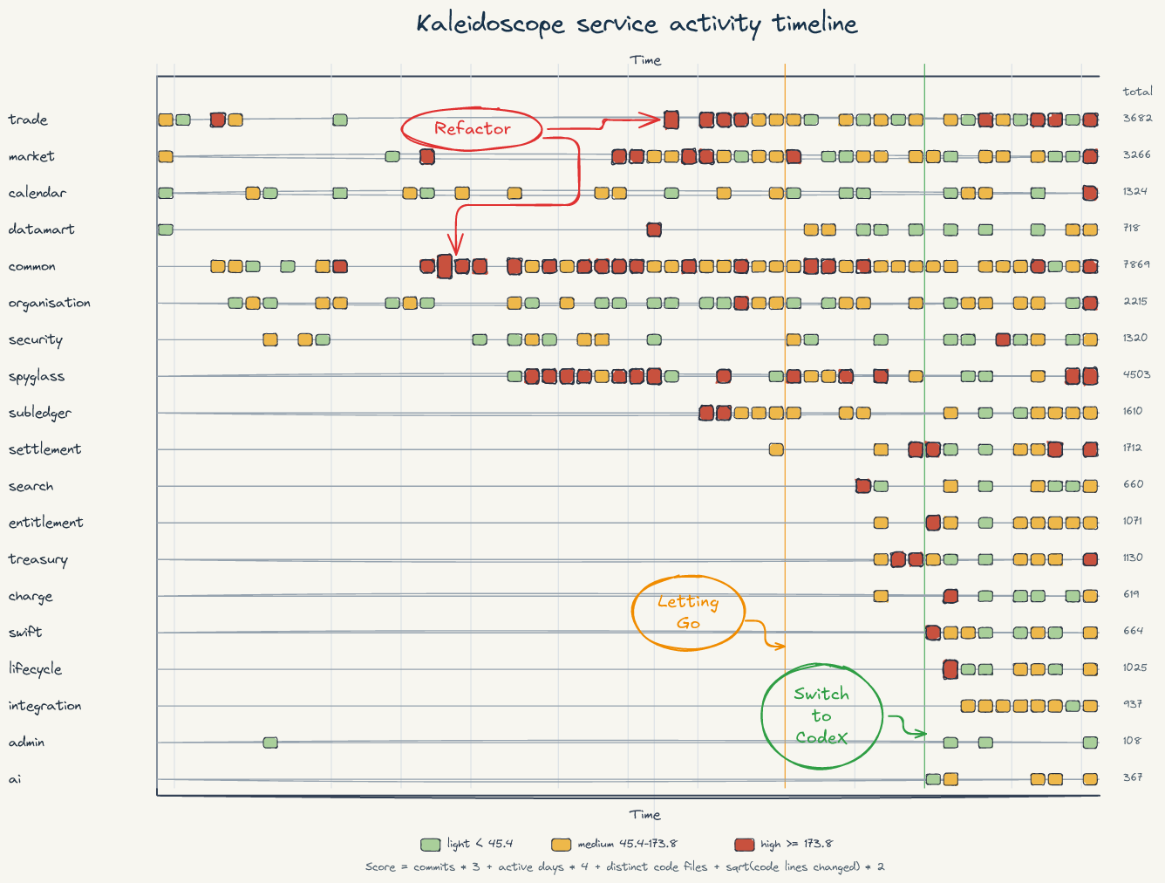
At the beginning of the project, I micromanaged the work. I wanted the framework, naming conventions, architecture, test style, and boundaries to be clear. That was the blueprint. Once the patterns emerged, I could loosen control and review results at a higher level.
The “rule of three” was useful. When functionality appeared three times, I looked for the underlying pattern and refactored. Sometimes the commonality was obvious from the start and belonged in a shared library. Sometimes it emerged only through development.
Transactions and events were a good example. They eventually unified trades, cash, entitlements, and lifecycle activity. The more the system developed, the more it became clear that a trade is not just a static record. It is a series of temporal events, some of which may or may not happen, generating zero or more transactions depending on the terms of the trade.
That insight supports both simple trades and highly structured trades. But an LLM is unlikely to give you that model on the first pass. It can help you explore it. It can challenge it. It can generate alternatives. It still needs a human who understands the domain deeply enough to connect the dots.
The same is true technically. Developers often create separate processes for exceptions, approvals, manual tasks, and investigations. AI will follow that habit because it has seen that habit. A human can notice that many of these are variations of workflow. Then several patterns become one pattern.
Less code. Fewer exceptions. More consistency. Better AI results.

BDD was the surprise
Behaviour-driven development became one of the strongest accelerators in the project.
LLMs perform best when the problem domain constrains the space of valid outputs. BDD does exactly that. Given/When/Then scenarios describe expected behaviour in clean language. They become executable specifications and living documentation.
For this project, most testing used BDD. Modules ran in test mode with controlled time and test endpoints. Feature scripts exercised the behaviour. Module-level steps could later be reused in integration-level tests.
This changed the development experience. Testing became part of the design process rather than an afterthought. AI could help write scenarios from domain knowledge, generate step definitions, implement missing behaviour, and then iterate against failures.
The key is test data discipline. You need a well-defined set of test data that can be extended. Test cases should be isolated enough to run in any order, while still representing realistic overlaps in the domain. That takes planning, but it pays back many times over.
The result was confidence without the brittleness that often comes from excessive low-level unit tests. If the BDD suite passes across the relevant workflows, you have meaningful evidence that the system behaves as expected.

Conclusion: stay on the path
AI is only probability, so stack the deck in your favour.
Stay within the bell curve. Use boring, well-documented technologies. Keep the domain language clean. Build around known patterns. Constrain the model with executable specifications. Review aggressively. Refactor when repetition appears. Treat AI agents as users that need permissions, workflows, and audit trails.
Most of all, use AI to amplify engineering discipline rather than bypass it.
The surprising result is that the beginning may feel slower. There is more hand-holding, more pattern-setting, more review, and more deliberate structure. But once the path is clear, the speed changes dramatically. Modules that would previously have taken weeks can become days.
That is the lesson I would take into any serious AI-assisted enterprise build: do not ask the model to invent the path. Build the path, then let it move quickly.

